*Neurophysiological responses to facial stimuli in light of experienced and committed aggression throughout the lifetime*

Donald Lyons & Nicole Sullivan

THE UNIVERSITY OF CHICAGO

*J U N E 2 0 1 7*

*A paper submitted in partial fulfillment of the requirements for MACS 40700*

Professor: Benjamin Soltoff

Introduction

Considerable evidence exists linking childhood maltreatment with aggression in adulthood, termed the “cycle of violence” (Silver et al., 1969; Lisak et al. 1996; Chen et al., 2012); likelihood of criminality is increased an estimated 50% in those who experienced maltreatment in childhood (Caspi et al., 2002). However, despite this strong association, it has been found that environment alone does not sufficiently explain adult aggression. One study of 18,083 twins in Sweden found that the association between childhood maltreatment and criminal offending as an adult was greatly attenuated when maltreated twins were compared to their non-maltreated counterparts versus when they were compared to unrelated controls, indicating that inborn or early environmental factors (other than abuse) may be responsible for a greater proportion of violent tendencies than was previously thought (Forsman and Långström, 2012). In another study, this time of 975 Caucasian twin boys, Cohen et al. (2006) found that a low-activity polymorphism in the monoamine oxidase A (MAOA) gene was associated with a higher mental health problem score than boys who were physically abused but possessed the high-activity MAOA polymorphism. Though findings thus far are still somewhat conflicting (Vassos, 2014), it is widely agreed that the biological and genetic contributions to human aggression have been underestimated in the past, while impact of childhood maltreatment has been overemphasized (Guo et al., 2008; Meyer-Lindenberg et al., 2006; Davidson et al., 2000; Siever, 2008).

Though genetic differences in resilient individuals are highly enlightening, studies combining genetic and environmental measures possess some shortcomings, the most important of which is that they do not capture more malleable and stimulus-dependent neurophysiological responses, and the way in which these responses serve as mechanisms for behavioral manifestations. In this study, we explore whether neurophysiological differences exist between adults who have experienced high levels of aggression, but do not have correspondingly high levels of aggression, and adults who have both high levels of experienced and committed aggression throughout the lifetime. This approach constitutes an approach into mechanisms of resilience complementary to genetic/environmental studies.

EEG research is uniquely suited to address the question of neurophysiological differences, as EEGs capture continuous electrical oscillations arising from assemblies of neurons as a result of neurotransmitter interactions. Oscillations can be portrayed in terms of, among other things, time against amplitude potential (μV) over time, or their frequency (cycles) over time against amplitude. When oscillations are portrayed as time against amplitude, waveforms following the stimulus are known as event-related potentials (ERPs), from which specific components can be isolated. Sensory-related components identified in the ERP are attributed to a variety of factors. Some sensory-related components appear in response to external factors, such as visual or auditory stimuli. Conversely, some sensory-related components, termed *endogenous* components, are related to internal factors, such as neural processing. The P3 component, in particular, has been well studied, and usually occurs with highest positive amplitude (depending on electrode) in response to a rare stimulus that has been jittered with other, frequent stimuli (known as an “oddball paradigm”; Luck, 2005). While the neural implications of P3 have been widely debated (Luck, 2005), P3 is most dominant in cases where probability of a target stimulus is low, and is greater amplitude is thought to indicate increased allocation of attentional and cognitive resources (Polich, 2007).

Transforming EEGs from time to frequency is also useful, as different frequencies are associated with various states or aspects of neural functioning. Frequencies are usually demarcated according to range: delta, δ (0.5-3.5 Hz); theta, θ (3.5-7 Hz); alpha, α (8-13 Hz); beta, β (18-25 Hz); and gamma, γ (30-70 Hz) (Başar et al., 2013). While β- and γ- waves are considered “local EEG modes” and span a limited topographic space, δ-, θ-, and α-waves are known as “global modes”, arising more broadly across the cortical surface, and integrating information from more distant neural assemblies (Knyazev, 2006). Considerable evidence shows an ordinal ordering of band predominance in accordance with the human circadian pattern; that is, β usually predominates in alert, focused waking hours, with a transition to α dominance when individuals are relaxed, and not working or consuming a great deal of cognitive resources. Transition to a resting state or light sleep is accompanied by θ waves, and deep sleep is associated with a move to δ, or extremely low-frequency slow waves (Buzsáki and Draguhn, 2004).

α-waves, also called Berger’s Waves after the neurologist responsible for recording the first EEG, have been well studied since the advent of EEG in 1929 (Karbowski, 2002). Because an inverse association between amplitude (also called power) and cognitive load was observed, it was originally thought that an increase in α power was indicative of lesser cortical activity, a framework of thought that came to be known as the “idling hypothesis” (Başar et al., 1997). However, a number of studies have since contradicted this hypothesis, demonstrating that an increase in α power is related not to inactivity but rather to active suppression of attention to irrelevant stimuli or “withhold[ing] or control[ling] execution of a response”, known as event-related synchronization or ERS (Klimesch et al., 2007; Klimesch, 2012).

An increase in α power accompanied by suppression of attention, known as an alpha “burst,” (Gruzelier, 2009), is often most often achieved in activities with low cognitive load and well-rehearsed motor skills (Del Percio et al., 2009, 2010, 2011a, 2011b). For some activities, this attention suppression has been shown to have distinct advantages. When athletes exhibit an alpha “burst” prior to executing automatic motor movements, their performance is enhanced. Meanwhile, comparatively lower amplitude α-waves have been shown to precede awry athletic performance. In fact, studies have shown that performances of athletes can be predicted based on amplitude of α-wave prior to the task. Golfers, for instance, exhibited higher amplitude high-frequency α prior to successful putts in comparison to unsuccessful putts, regardless of the golfer’s balance (Babiloni et al., 2008). Similarly, accuracy of expert air-pistol marksmen was highest when following increasing α power (from baseline), while decreasing α power precipitated shots with lowest accuracy (Loze et al., 2001).

Moreover, increased α power as a mechanism of decreased attention has also been shown to enhance creativity. When mental performances of improvisational dance (which demands a high level of creativity) and the waltz (a monotonous, highly choreographed dance demanding low levels of creativity) were compared between expert and novice dancers, higher levels of α synchronization in the right hemisphere accompanied expert improvisations compared to novices’ improvisations (Fink et al., 2009). Similarly, augmenting 10 Hz α in the frontal cortex using transcranial alternating current stimulation (tACS) resulted in a significant improvement as measured on a widely-used index of creative potential and ability (Lustenberger et al., 2015).

While suppression of attention during an α burst gives rise to enhanced creative thought and well-rehearsed performances, a decrease in α-amplitude is associated with increased cognitive activity. Kelly et al. (2008) facilitated a tonic decrease in α power via ingestion of 100 mg of the tea extract L-theanine and 50 mg of caffeine. After the decrease in α power, participants demonstrated increased accuracy in a task involving stimulus discrimination.

Only a few studies to date have studied α-EROs in response to facial stimuli, and only one known study has studied the differential α-EROs between a high-hostility and low-hostility group in response to facial stimuli (Balconi and Lucciari, 2006; Güntekin and Başar, 2007; Knyazev et al., 2009). Regarding responses in all bands to happy, angry and neutral expressions, Güntekin and Başar (2007) found that angry expressions elicited higher amplitude α than other countenances. Knyazev et al. (2009), found that amplitudes of α were significantly higher among a group of individuals rated high in hostility than those rated low in hostility. However, the groups were only different when amplitudes were averaged across all cortical sites and time points.

In the current study, we hypothesized, based on the findings of Knyazev et al. (2009), that aggressive individuals would exhibit higher α-amplitude in response to visually threatening stimuli; we had no hypotheses concerning those with low committed aggression, but high experienced aggression, as we found no literature on α-EROs of individuals with this background. We presented participants with photographs of faces displaying an angry countenance, or a happy expression. The angry faces were displayed infrequently and at random between frequent happy faces. This presentation was intended to mimic emotions similar to those precipitating a verbally or physically aggressive confrontation. The period *following* the stimulus, then, was treated as the period prior to a potential encounter. We predicted that α amplitude would increase as a function of increasing aggression. This prediction was made on basis of the relationship between α amplitude and attentional suppression “in response to stimuli that must be ignored” (Klimesch, 2012). Higher α amplitude would be taken as an indicator of “automatic” or “unthinking” responses with well-rehearsed movements.

Methods

*Participants and Questionnaires*

49 subjects (61.2% African American, 30% Hispanic, 24.5% Caucasian, and 4.1% Asian/Pacific Rim; 17 = female, 32 = male), aged 21-55, participated in the study. Participants completed medical and physical health questionnaires, and underwent comprehensive psychiatric interviewing with a trained clinician possessing, at a minimum, a Master’s degree. During prescreening, they completed the Lifetime History of Aggression, a measure of severity and prevalence of aggression, as well as antisocial behavior and self-injury. Interrater agreement using the assessment is high (ICC = 0.94), as is test-rest reliability (r > 0.80) and internal consistency (0.87; Coccaro et al., 1997). Subjects also completed a battery of behavioral questionnaires, including the Lifetime History of Experienced Aggression (LHEA).

The LHEA asks the participant to estimate the number of times in which the participant experienced the particular instance described. Situations include either verbal or physical assault on their person or property from a family member or non-family member – on a 0-5 scale (0 being “0 events”, 5 being “so many events they can’t be counted”) for three age categories (childhood: 0-12 years; adolescence: 13-18 years; adulthood: 18+ years). For this study, we used the aggregated score (used in this study), which had a possible range of scores from 0 (no experience of aggression throughout the lifetime) to 150 (countless experiences of every instance described in childhood, adolescence, and adulthood; see LHEA-S, Appendix II).

*Task*

During the first EEG task, participants viewed faces expressing happy, neutral, or angryemotions. Photographs of faces were from the Ekman series, an anthology of faces that has been anatomically standardized and cross-culturally validated (Ekman and Friesen, 1976; Ekman, 1977)*.* Stimuli were displayed on a 19-inch CRT computer screen for 1500 ms, followed with a blank screen for 1000 ms, and then a fixation cross following the blank screen for another 1000 ms. Participants viewed two blocks. In one block, frequent happyfaces were jittered with rare angryface (designated as the “angry task” in Results); in the other block, frequent happy faces were jittered with rare neutralfaces (designated as the “neutral task”). Ratio of frequent to rare stimuli in both blocks was 3:1. The sequence of blocks was random and counterbalanced across participants. Overall, 320 face stimuli were presented. Both the frequent and rare images contained the same 2 faces (1 Caucasian male, 1 Caucasian female), matched across blocks, modeling different emotions.

*EEG Collection*

EEG recordings used 128 sintered Ag/AgCl active electrodes (ActiveTwo™ system, BioSemi B.V., Amsterdam), snapped onto a headcap with an equiradial design following gel application. Reference electrodes around the eye and on the sternum were used to determine at where data were obscured due to eyeblinks and heartbeats, respectively. Electrode leads were connected to a battery-powered analog-to-digital box. Digital acquisition of electrodes’ topographical locations in relation to head shape was performed via a PatriotTM Digitizer Stylus (Polhemus Co., Colchester VT) and Locator software (Source Signal Imaging, Inc., San Diego CA). EEG data was collected continuously, amplified, and subsequently digitized using Biosemi ActiveView software. Recordings then underwent high pass filtering (0.05 Hz), and low pass filtering (30 Hz, -12 dB/octave) to eliminate superfluous noise. Voltage-restricted amplifiers were used to process EEG signals, which were digitized (16 bit/ 500 Hz sampling rate) for storage and later analysis.

*EEG Preprocessing*

Muscular artifacts were defined manually in Brain Electrical Source Analysis (BESA) software with a filter of 53-200 Hz. Trials containing artifacts were omitted during subsequent analyses. Interpolation was used to average the activity of neighboring channels with excessive non-neural noise. ICA was run on a 60-s window with no muscular artifacts and a 53-200 Hz filter to identify components corresponding to EKG, blink and HEOG artifacts.

For analysis of ERPs, mean amplitude of the waveform, in relation to a -200 to 0 ms baseline, was exported for the 300-600 ms following event. Time window of 300-600 ms was chosen based on the grand mean of all subjects across all electrodes and events. Analysis for ERP data was conducted on the Fz, Cz, and Pz electrodes, following precedent in the literature (Fanning et al., 2014).

For analysis of ERD/ERS, the waveform was decomposed into frequencies using the Fast Fourier Transform (FFT) method in BESA (δ: 1.0-4.0 Hz; θ: 4.0-8.0 Hz; α: 8.0-14.0 Hz; β: 14.0-20.0 Hz; γ: 30.0-50.0 Hz) for the 1000 ms epoch following the appearance of the facial stimulus (event). While traditional approaches recommend a relative scale when referring to power changes, with baseline set at either 0% or 100% (Pfurtscheller and Silva, 1999; Balconi and Lucchiari, 2006), absolute power has also been used in studies, particularly of α waves (Loze et al., 2001

Results

*Analysis of P3 ERP Component*

To determine the impact of covariates on amplitude of the P3 component, if any, an analysis of variance (ANOVA) with task (angry or neutral), expression (angry, neutral, or happy), and electrode (Fz, Cz, and Pz) as the within-subjects factors, and covariates of sex, race (Caucasian, African American, Asian/Pacific Rim, Hispanic), and age was conducted. Expression was task-dependent, and rare stimulus within each task was used for designation of that task; that is, the task designated “angry” contained a 3:1 ratio of happy and angry faces, while the neutral task contained the same ratio of happy to neutral faces.

The analysis found several significant interactions (see Table 1), but no significant main effects. Four follow-up ANOVAs, two for each task (neutral vs. angry) with a separate covariate (sex or race) and expression included as a within-subject factor, were performed in order to further investigate interactions. While no significant main effects were found for either sex or race, there was a significant main effect for expression in both analyses of race; *F*(1, 44) = 4.497, *p* < 0.05 in the neutral task, and *F*(1, 46) = 8.361, *p* < 0.01 in the angry task. There was also a significant main effect of electrode in the analysis of race in the angry task, *F*(1, 46) = 6.459, *p* < 0.01, and a significant interaction between expression and race, *F*(1, 46) = 7.056, *p* < 0.05.

In order to evaluate differences between age groups depending on task, expression, and electrode two independent samples *t*-tests containing the aforementioned variables were performed, with subjects split into two groups based on median age (38 years; for younger group, age > median, for older, age ≤ median to achieve equivalent group sample sizes). No significant differences were found across groups for task, expression or electrode.

To assess the effect of aggression on amplitude differences in P3, an ANOVA was performed with task, expression, and electrode as the within-subjects factors. While there was a significant interaction between expression and race in the angry task, because race differences were not of interest in these analyses, covariates were excluded from analysis. The analysis found a main effect of expression, *F*(1, 39) = 21.405, *p* < 0.001, a main effect of electrode, *F*(2, 78) = 9.046, *p* < 0.001, and an interaction effect between task and expression, *F*(1, 39) = 4.953, *p* < 0.05. All main effects or interactions related to LHA scores were non-significant.

To explore the relation of experienced and witnessed aggression to amplitude of P3, we performed another ANOVA with the same within-subjects factors as the previous ANOVA, and LHEA and LHWA scores rather than LHA. The analysis found no significant main effects or interactions related to LHEA or LHWA.

*Investigating α event-related desynchronization*

I. Regarding Autocorrelation of Observations

Regression was highly desirable in examining *α-*ERD, as sign of coefficient would indicate direction of amplitude with increasing LHA or LHEA score. However, because of the proximity of electrodes, it was expected that residuals would exhibit autocorrelation, violating the independence of errors of assumption in linear regression. To test the strength of relationship between successive observations, Durbin-Watson’s test was used. The *d*-statistic was approximately 2 and highly significant (*d* = 2.387, *p* < 0.00001); therefore, we did not find evidence of autocorrelation (Chatterjee and Hadi, 2012).

1. Preliminary Analyses Omitting Variables of Interest

We proposed a model (1), below. The model contains dummmy variables laterality (L), axis (A), task (T) and expression (E), where subscripts indicate when indicators equal 1 (middle, right, frontal, parietal, theta, neutral, neutral and happy, respectively). The model also includes Σα, which, for succinctness, denotes every possible interaction between all indicators in the model. Model 1 was evaluated first, in order to determine if any interactions were presented prior to the addition of variables of interest. Note that subject was controlled for via the inclusion of variable *κ.*

*Yamplitude* = *β0* + *γM LM* + *γRLR* + *δAAF* + *δAAP* + *ςTN* + *ηNEN* + *ηHEH* + *κ* + Σα + ε

Though a repeated-measures ANOVA could, alternatively, have been conducted, as values for different conditions were evaluated separately, multivariate regression was also suitable, and as sign of the coefficient for LHA was of interest (see later analyses), multiple linear regression was therefore chosen.

No significant interactions were found. Though significant interaction between laterality, expression, and axis (based on α asymmetry research) was expected, because variance was split between a large number of variables (the model considers 28 interactions in total), it was not surprising that the model found no differences based on laterality, expression and axis.

Because no significant interactions were found in the full model, and because including impertinent multiplicative functions needlessly tax the precision of the model, interactions were removed from the full model, producing the reduced model (2)

*Yamplitude* = *β0* + *γM LM* + *γRLR* + *δAAF* + *δAAP* + *ςTN* + *ηNEN* + *ηHEH* + *κ +* ε

Laterality was found to be a significant predictor of α-amplitude variance (*γM* = 10.65, *p* < 0.0001), as well frontal electrodes (*δA* = -5.814, *p* < 0.0001). An analysis of variance (ANOVA) was performed between the two models to determine if the reduced model, sans interactions, was significantly different from the full model. The ANOVA found the two models were not significantly different (Table 2***).*** To ensure interactions were negligible in this model, an ANOVA was performed against the nullity of all interactions in model. No interactions were significant.

III. α-ERD models with LHA/LHEA

Based on analyses testing nullity of interactions, model (3), below, containing LHA score as a variable and significant interactions was constructed, where

*Yamplitude* = *β0* + *γM LM* + *γRLR* + *δAAF* + *δAAP* + *ςTN* + *ηNEN* + *ηHEH* + *βLHAXLHA* +

*κ* + α1(*LM*×*XLHA*) + α2(*LR*×*XLHA*) + ε

This model was chosen for several reasons: first, interactions were not significant either in the full model, or in the ANOVA of interactions. Second, the model already divides the variance between a large number of variables. Third, the interaction of laterality with variables aside from axis and LHA were not of interest in this study.

It should be noted that though technically LHA is a discrete variable (it cannot take values between whole integers), it was treated as a continuous variable because response of amplitude was not assumed to be proportional for each successive increase in LHA, as would be the case if LHA were treated as an ordinal predictor. Moreover, an analysis treating LHA as discrete found all levels to be significant except for scores of 4, 10, 16, and 22.

LHA as a predictor of variance was highly significant (estimate of *βLHA* = -11.68, *p* < 0.005); however, it should be noted that despite the finding, via the DW test, that there was no evidence for autocorrelation, a pattern was visually detected based on the spatial proximity of electrodes (Fig. 3). Therefore, the significance of this finding should be treated with caution. However, no significant interactions between laterality and frequency were found, nor were any interactions between LHA and frequency found, as it was originally thought. Based on the significance of LHA in predicting amplitude, and investigation of differences in responses to specific stimuli and in specific circumstances was conducted.

V. Relationship of LHA to Response to Threatening or Unexpected Stimuli

When the responses to angry face were analyzed separately for each axis (frontal, central, or parietal electrodes), with LHA score as predictor, and no interactions, LHA was not significant (Fig. 8). When amplitude in response to rare stimuli only (the angry face jittered with frequent happy faces, and the rare neutral face jittered with frequent happy faces) was analyzed separately for each axis, with LHA scores and expression as predictors, neither expression nor LHA score were significant predictors of amplitude (Fig. 8-9). Therefore, the current models were not able to detect any significant differences in α amplitude in response to angry faces, or relatively infrequent faces, based on one’s committed aggression throughout the lifetime.

VI. Concerning LHA and LHEA

Because experienced aggression is known to be highly related to committed aggression, it was thought that collinearity would likely interfere with results if a model included both scores of experienced aggression and committed aggression as an interaction, though interaction of the two variables was of particular interest in part VII. To test this hypothesis, two models were built, one in which committed aggression was regressed on experienced aggression, and the other in which experienced aggression was regressed on committed aggression. Both models are reasonable, but based on different suppositions about mechanisms that could relate experienced and committed aggression. According to the cycle of violence theory, experienced aggression is highly predictive of later committed aggression. Alternatively, it may also be that those with aggressive tendencies may initiate more aggressive interactions, resulting in a higher experienced aggression score.

In *YLHA* = *β0* + *βLHEA,* both estimated *β0* and estimated *βLHEA* were highly significant, while in *YLHEA* = *β0* + *βLHA*, *β0*was non-significant, indicating that it is unlikely that a linear relationship exists between low LHA and LHEA. To evaluate form of the predictors' relationship, LHA was plotted against LHEA (Fig. 4). While transformation of the data would be necessary to meet the linearity assumption, collinearity of LHA and LHEA was manifested. Next, homoscedasticity of each predictor in the full model was assessed visually (Fig. 5 and 6). Because the variables were discrete, and, in essence categorical, they appear in columns in the plots; however, no noticeable trends occur in tandem with an increase or decrease in LHEA or LHA. Therefore, it was determined both variables were suitable for subsequent regression.

VII. Exploratory Analysis Concerning Those with High LHEA, and Low LHA

Because LHA and LHEA are correlated, including both variables together in a model to evaluate the interactive effects of LHA and LHEA on α amplitude would violate assumptions of linear independence (see section VI). For this reason, it was necessary to create two groups, one with low LHA and high LHEA (low committed aggression, high experienced aggression), and one with high LHA and high LHEA (high committed and experienced aggression scores). When amplitude of the alpha band was regressed on group, task, and expression separately for electrodes Cz, Pz and Fz (because no effects of laterality or axis were found in previous models), group (low LHA/high LHEA versus high LHA/high LHEA) was not found to be a significant predictor of amplitude (Tables 3-5; Fig. 10-11).

Discussion

Analyses of ERP components confirmed appearance P3 across all subjects and tasks in response to the oddball design of the experiment. Significant interaction effects between task and electrode, and electrode and expression in the first full model ANOVA (containing sex, age, and race as covariates) confirmed the success of the oddball paradigm (Table 1; Fig. 1 & 2). When interactions involving sex and age were further investigated via unique ANOVAs for each task and covariate, both sex and age were found to be non-significant. Race interactions were found to be significant. However, upon further ANOVAs, we conclude this result is probably due to the differences between participants of Asian/Pacific Rim descent and other ethnicities (see Fig. 7). Furthermore, the sample size for this participants of Asian/Pacific Rim descent was extremely small (*n* = 2), and therefore, while differences are currently significant, it is probable that they are not representative of the population.

Based on these preliminary investigations, it was assumed that collapsing across different sexes, ages, and races would not overly confound results. ANOVAs excluding these covariates examined the relationship, first, between LHA and P3 amplitude and, second, between LHEA, LHWA and P3 amplitude. Though no significant main effects were found for the variables of interest, it is possible that a more comprehensive model would have found differences based on these variables.

Analyses of α*-*ERD found that amplitude did not vary significantly as a function of LHA score, and that it did not vary significantly between low LHA/high LHEA, high LHA/high LHEA groups. There are a number of explanations for these findings: it could be that the changes in the amplitude in the α frequency do not occur in a linear fashion. We used linear regression and general linear models for analyses, and these models can only account for linear trends. That is, we found when committed aggression is treated as a spectrum rather than as presence or absence of a trait (as in studies comparing “non-aggressive” or “aggressive”), there is no linear trend specific to aggression scores as measured via the LHA. It might be that α response to the stimulus was confined to such a narrow temporal window that averaging over the 1000 milliseconds following the stimulus effectively collapsed out the small amount of time-specific variance in responses; future studies epoching the data into 100 ms windows following the stimulus (rather than averaging the 1000 ms following, as we did) will provide further detail on differences in α-EROs during facial processing.

Another explanation is, in the few experiments that have studied ERO in facial processing, electrode amplitudes were usually averaged over a large number of sites. Knyazev et al. (2009) reported significance after averaging over all cortical sites and time points. However, it may be that amplitudes do not significantly differ from one another based on aggression when each electrode is considered discretely.

An additional concern is that the paradigm may not sufficiently extend its validity to exogenous environments – that is, viewing static photographs of unfamiliar white faces on a screen is vastly different from experiencing angry or threatening behavior in a real-life encounter, and, therefore, this paradigm may not elicit a response reliable enough to be observed in a more diverse sample that more closely maps onto the population at large. Race demographics were not reported in previous studies, but they took place in regions where a majority of the population was white; therefore it is assumed that the sample was likewise white.

Lastly, the standard procedure in EEG preprocessing is to average hundreds of trials, which removes noise, but also, by extension, removes any information about the reliability of the mean, or its ability to accurately represent the hundreds of waveform amplitudes seen in the milliseconds following stimuli. That is, amplitudes, even intra-individual, are highly variable, but in ERP and oscillation studies, one mean amplitude over hundreds of trials signifies the “true” amplitude response of the individual to that stimulus, though standard errors of that mean, or standard deviations of the amplitudes gathered from these trials are not reported, and standard errors or standard deviations of the group means are rarely reported (Luck, 2005; Loze et al., 2001). Luck (2005) notes that when latencies of waveforms differ by even fractions of milliseconds, averages can produce “distorted views of the single-trial waveforms” and that researchers should never assume that “an averaged…waveform accurately represents the individual waveforms that were averaged together.” Concerning ERP experiments alone (and not ERO experiments), Luck says,

It is worth mentioning that a very large number of published ERP experiments have violated [rules of ERP]. There is no point in cataloging the cases (especially given that the list would include some of my own papers). However, violations of these rules significantly undermine the strength of the conclusions that one can draw from these experiments.

This study, then, calls into question differences in α-EROs in relation to facial processing between individuals classified as belonging to “aggressive” or “non-aggressive” groups. While ERO research has provided reliable and satisfactory answers to questions concerning neurological disorders, it may be that it is less well suited to impulse-control disorders, and that techniques used in past studies may have violated certain assumptions of waveform research (such as averaging across all electrode sites). Further studies utilizing correct ERP/ERO preprocessing and analysis techniques, and epoching the data into a greater number of windows following the stimulus are needed to shed light on the presence or absence of frequency-dependent neurophysiological differences in resilient non-aggressive individuals versus highly aggressive individuals.

Appendix I: Tables & Figures

|  |  |  |  |  |  |
| --- | --- | --- | --- | --- | --- |
| *Table 1: ANOVA of Within-Subjects Factors & Covariates for ERP Mean Amplitude* | | | | | |
| *Source* | *Type III SSE* | *df* | *Mean Square* | *F* | *Sig.* |
| Task | 0.233 | 1 | 0.233 | 0.087 | 0.769 |
| Task*Age | 0.612 | 1 | 0.612 | 0.229 | 0.635 |
| Task*Sex | 0.002 | 1 | 0.002 | 0.001 | 0.979 |
| Task*Race | 0.067 | 1 | 0.067 | 0.025 | 0.875 |
| Expression | 6.6 | 1 | 6.6 | 3.321 | 0.076 |
| Expression*Age | 4.725 | 1 | 4.725 | 2.378 | 0.131 |
| Expression*Sex | 2.436 | 1 | 2.436 | 1.226 | 0.275 |
| Expression*Race | 1.553 | 1 | 1.553 | 0.781 | 0.382 |
| Electrode | 6.936 | 1.64 | 4.229 | 0.848 | 0.413 |
| Electrode*Age | 6.544 | 1.64 | 3.99 | 0.801 | 0.431 |
| Electrode*Sex | 0.918 | 1.64 | 0.56 | 0.112 | 0.856 |
| Electrode*Race | 2.651 | 1.64 | 1.616 | 0.324 | 0.681 |
| Task*Expression | 0.174 | 1 | 0.174 | 0.139 | 0.711 |
| Task*Expression*Age | 0.012 | 1 | 0.012 | 0.01 | 0.922 |
| Task*Expression*Sex | 1.127 | 1 | 1.127 | 0.904 | 0.347 |
| Task*Expression*Race | 0.531 | 1 | 0.531 | 0.426 | 0.518 |
| Task*Electrode | 2.236 | 1.774 | 1.261 | 5.362 | 0.009** |
| Task*Electrode*Age | 2.445 | 1.774 | 1.378 | 5.862 | 0.006** |
| Task*Electrode*Sex | 1.992 | 1.774 | 1.123 | 4.776 | 0.014* |
| Task*Electrode*Race | 0.747 | 1.774 | 0.421 | 1.792 | 0.178 |
| Expression*Electrode | 2.838 | 1.325 | 2.143 | 8.774 | 0.002** |
| Expression*Electrode*Age | 1.442 | 1.325 | 1.088 | 4.457 | 0.041* |
| Expression*Electrode*Sex | 0.385 | 1.325 | 0.291 | 1.191 | 0.295 |
| Expression*Electrode*Race | 1.524 | 1.325 | 1.15 | 4.71 | 0.025* |
| Task*Expression*Electrode | 0.047 | 1.289 | 0.037 | 0.295 | 0.648 |
| Task*Expression*Electrode*Age | 0.118 | 1.289 | 0.092 | 0.735 | 0.428 |
| Task*Expression*Electrode*Sex | 0.105 | 1.289 | 0.081 | 0.649 | 0.461 |
| Task*Expression*Electrode*Race | 0.416 | 1.289 | 0.323 | 2.581 | 0.106 |

*Table 2: ANOVA of Full Model vs. Reduced Model*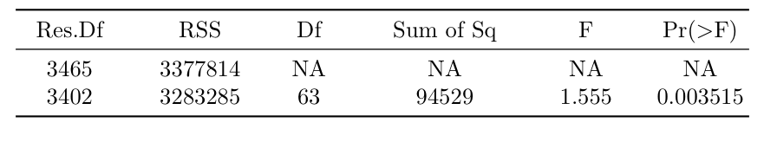

*Table 3:* α*amplitude regressed on LHA/LHEA group at the Pz electrode in response to angry faces*

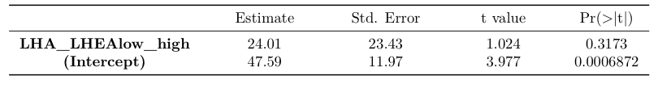

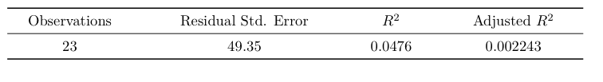

*Table 4:* α*amplitude regressed on LHA/LHEA group at the Fz electrode in response to angry faces*

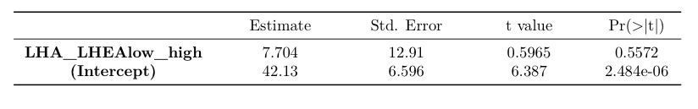

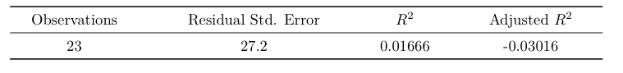

*Table 5:* α*amplitude regressed on LHA/LHEA group at the Cz electrode in response to angry faces*

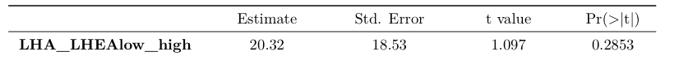

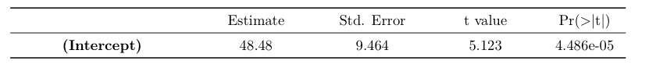

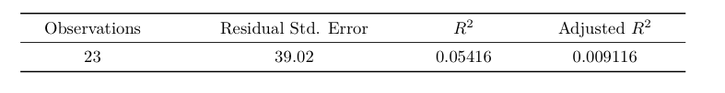

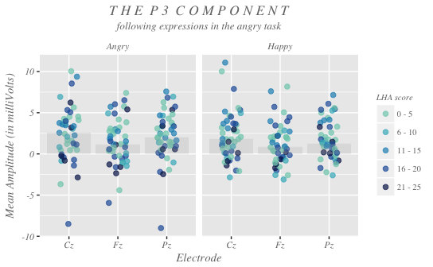

*Figure 1: Stripchart of the experimental condition*

*Figure 2: Stripchart of the control condition*

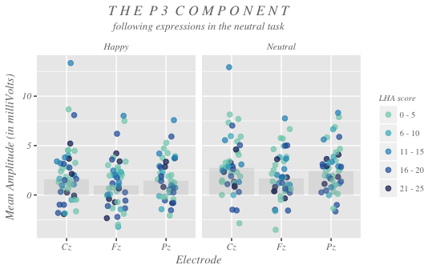

*Figure 3: Index Plot of the Residuals*

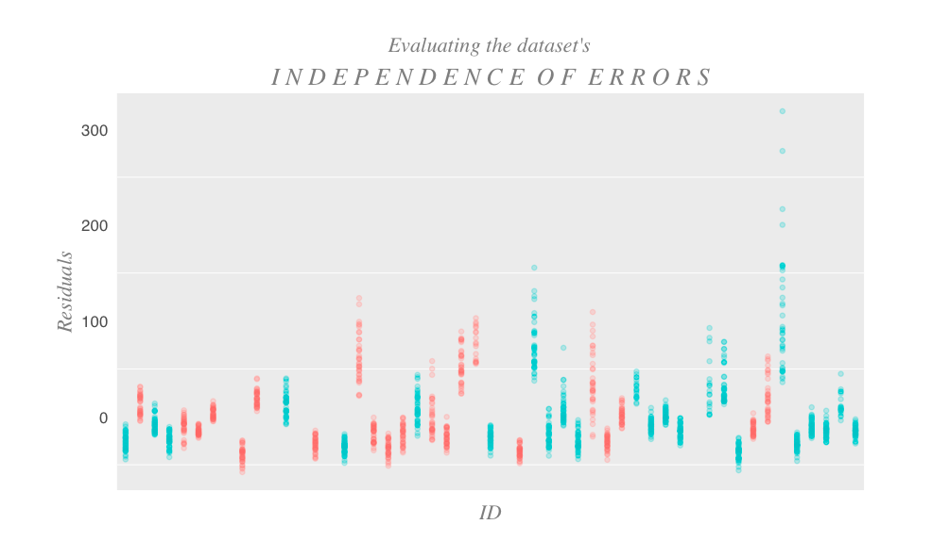

*Figure 4: Committed Aggression vs. Experienced Aggression*

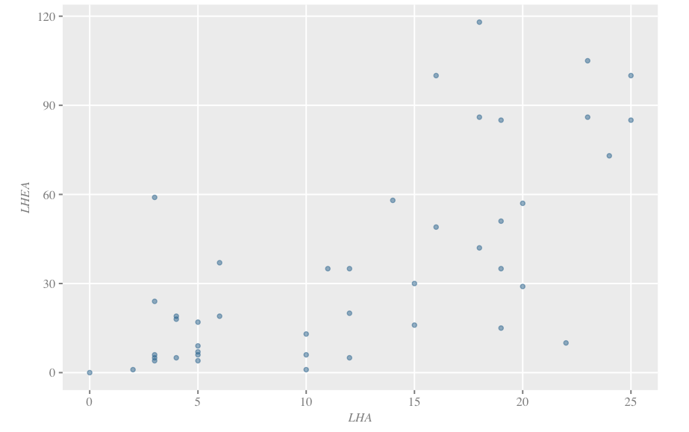

*Figure 5*

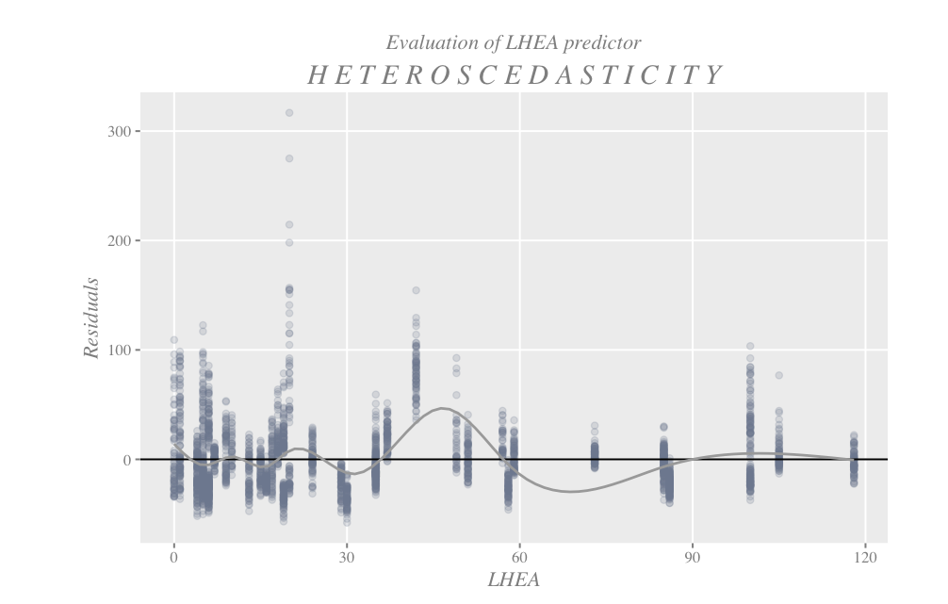

*Figure 6*

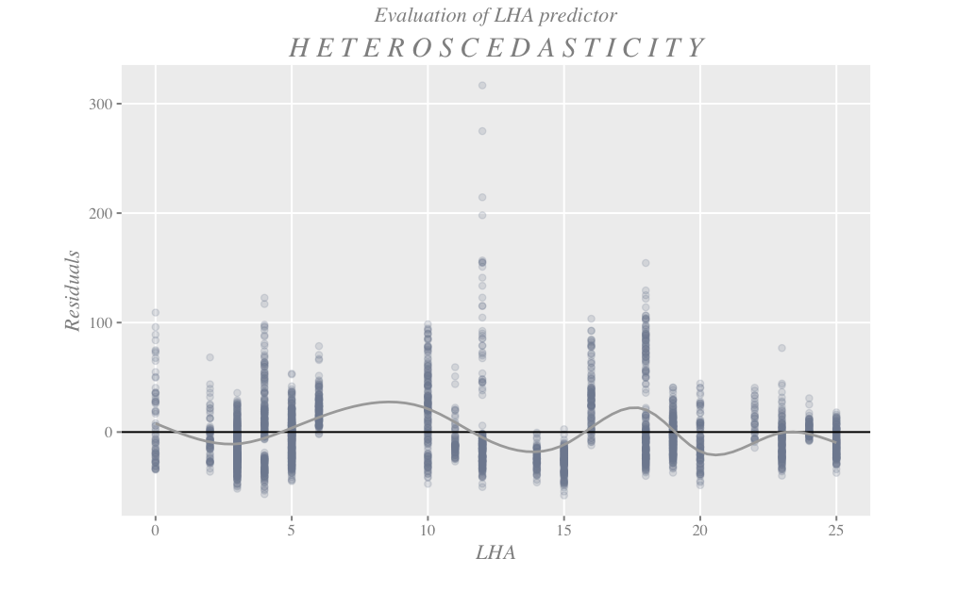

*Figure 7: Boxplot of Race Differences in Angry Task*

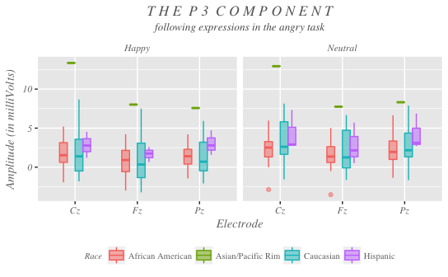

*Figure 8*

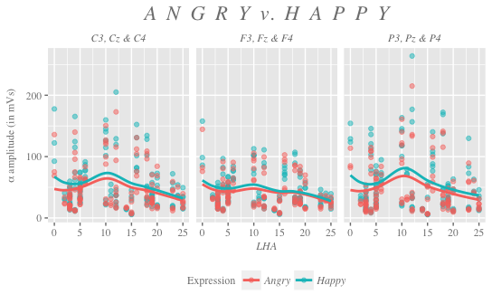

*Figure 9*

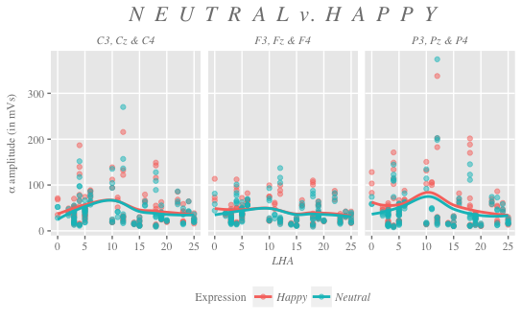

*Figure 10*

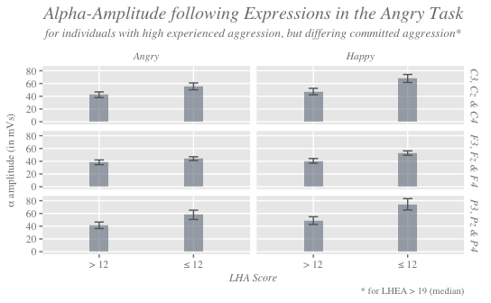

*Figure 11*

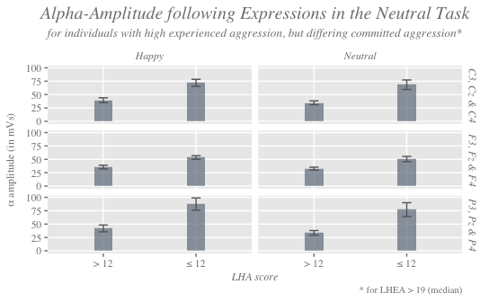

Appendix II: Survey

**LHEA-S**

**Instructions:** Rate yourself on each of the following items using the rating system below. Only rate actual behavior be it verbal and/or physical. For these questions, please rate all events that have occurred during the periods listed: **Childhood (0-12 years), Adolescence (13-18 years), Adulthood (18 and up years)**.

0 = no events

1 = one event

2 = "a couple" or "a few" (i.e., 2-3) events

3 = "several" or "some" (i.e., 4-9) events

4 = "many" or "numerous" (i.e., 10+) events

5 = "so many events that they can't be counted"

**How Many Times Would You Say You Experienced the Following Things**

**During the Time Period Listed?**

**Item Categories for “WITHIN FAMILY AGGRESSION DIRECTED AT YOU”**:

1. Temper Tantrums by a MEMBER OF YOUR FAMILY DIRECTED AT YOU (i.e. behavioral manifestations in response to frustration; screaming, ranting and raving, throwing things, etc.).

Childhood: _____ Adolescence: _____ Adulthood: _____

2. Verbal Fighting Begun by a MEMBER OF YOUR FAMILY DIRECTED AT YOU (e.g. history of verbal arguments in which an angry voice / profanity / insults threats are used; note that polite disagreements do not count).

Childhood: _____ Adolescence: _____ Adulthood: _____

3. Physical Assaults ON YOUR PROPERTY by a MEMBER OF YOUR FAMILY (i.e., throwing / breaking

objects).

Childhood: _____ Adolescence: _____ Adulthood: _____

4. Physical Assaults AGAINST YOU by a MEMBER OF YOUR FAMILY that DID NOT END in Physical Injury.

Childhood: _____ Adolescence: _____ Adulthood: _____

5. Physical Assaults AGAINST YOU by a MEMBER OF YOUR FAMILY that ENDED in Physical Injury.

Childhood: _____ Adolescence: _____ Adulthood: _____

**How Many Times Would You Say You Experienced the Following Things**

**During the Time Period Listed?**

0 = no events

1 = one event

2 = "a couple" or "a few" (i.e., 2-3) events

3 = "several" or "some" (i.e., 4-9) events

4 = "many" or "numerous" (i.e., 10+) events

5 = "so many events that they can't be counted"

**Item Categories for “OUTSIDE-OF-FAMILY AGGRESSION DIRECTED AT YOU”**:

6. Temper Tantrums of ANOTHER PERSON (NOT IN YOUR FAMILY) DIRECTED AT YOU (i.e. behavioral manifestations in response to frustration; screaming, ranting and raving, throwing things, etc.).

Childhood: _____ Adolescence: _____ Adulthood: _____

7. Verbal Fighting Begun by ANOTHER PERSON (NOT IN YOUR FAMILY) DIRECTED AT YOU (e.g. history of verbal arguments in which an angry voice / profanity / insults / threats are used; note: polite disagreements do not count).

Childhood: _____ Adolescence: _____ Adulthood: _____

8. Physical Assaults ON YOUR PROPERTY by ANOTHER PERSON (NOT IN YOUR FAMILY) (i.e., throwing / breaking objects).

Childhood: _____ Adolescence: _____ Adulthood: _____

9. Physical Assaults AGAINST YOU by ANOTHER PERSON (NOT IN YOUR FAMILY) that DID NOT END in Physical Injury.

Childhood: _____ Adolescence: _____ Adulthood: _____

10. Physical Assaults AGAINST YOU by ANOTHER PERSON (NOT IN YOUR FAMILY) that Did END in Physical Injury.

Childhood: _____ Adolescence: _____ Adulthood: _____

References

Babiloni C, Del Percio C, Iacoboni M, Infarinato F, Lizio R, Marzano N, Crespi

G, Dassu F, Pirritano M, Gallamini M, Eusebi F. 2008. Golf putt outcomes are predicted by sensorimotor cerebral EEG rhythms. J Physiol. 886.1: 131-139.

Babiloni C, Del Percio C, Rossini PM, Marzano N, Iacoboni M, Infarinato F,

Lizio R, Piazza M, Pirritano M, Berlutti G, Cibelli G, Eusebi F. 2009. Judgment of actions in experts: A high-resolution EEG study in elite athletes. NeuroImage. 45: 512-521.

Babiloni C, Infarinato F, Marzano N, Iacoboni M, Dassù F, Soricelli A, Rossini

PM, Limatola C, Del Percio C. 2011. Intra-hemispheric functional coupling of alpha rhythms is related to golfer’s performance: A coherence EEG study. International Journal of Psychophysiology. 82: 260-268.

Balconi M and Lucchiari C. 2006. EEG correlates (event-related

desynchronization) of emotional face elaboration: A temporal analysis. Neuroscience Letters. 392: 118-123

Başar E. 2013. Brain oscillations in neuropsychiatric disease. Dialogues in

Clinical Neuroscience. 15(3):291-300.

Başar E, Başar-Eroğlu C, Karakaş S, Schürmann M. 1999. Are cognitive

processes manifested in event-related gamma, alpha, theta, and delta oscillations in the EEG? Neuroscience Letters. 259: 165-168.

Başar E, Schürmann M, Başar-Eroğlu C, Karakaş S. 1997. Alpha oscillations in

brain functioning: an integrative theory. International Journal of Psychophysiology. 26: 5-29.

Boynton T. 2001. Applied research using alpha/theta training for enhancing

creativity and well-being. Journal of Neurotherapy. 5: 1-2, 5-18.

Buzsáki G and Draguhn A. 2004. Neuronal oscillations in cortical networks.

Science. 304: 1926-1929.

Caspi A, McClay J, Moffitt TE, Mill J, Martin J, Craig IW, Taylor A, Poulton R.

2002. Role of genotype in the cycle of violence in maltreated children. Science. 297: 851- 853.

Chatterjee S and Hadi AS. 2012. Regression Analysis by Example. Hoboken, NJ:

Wiley & Sons, Inc.

Chen P, Coccaro EF, Lee R, Jacobson KC. 2012. Moderating effects of childhood

maltreatment on associations between social information processing and adult aggression. Psychol Med. 42(6): 1293-1304.

Coccaro EF, Berman ME, Kavoussi, RJ. 1997. Assessment of life-history of

aggression: Development and psychometric characteristics. Psychiatry Research. 73: 147-157.

Coccaro EF, McCloskey MS, Fitzgerald DA, Luan Phan K. 2007. Amygdala and

orbitofrontal reactivity to social threat in individuals with impulsive aggression. Biol Psychiatry. 62: 168-178.

Davidson RJ, Putnam KM, Larson CL. 2000. Dysfunction in the neural circuitry

of emotion regulation – a possible prelude to violence. Science. 289: 591-594.

Del Percio C, Babiloni C, Bertollo M, Marzano N, Iacoboni M, Infarinato F,

Lizio R, Stocchi M, Robazza C, Cibelli G, Comani S, Eusebi F. 2009a. Visuo-attentional and sensorimotor alpha rhythms are related to visuo-motor performance in athletes. Human Brain Mapping. 30: 3527-3540.

Del Percio C, Babiloni C, Marzano N, Iacoboni M, Infarinato F, Vecchio F, Lizio

R, Aschieri P, Fiore A, Toran G, Gallamini M, Baratto M, Eusebi F. 2009b. “Neural efficiency” of athletes’ brain for upright standing: A high-resolution EEG study. Brain Research Bulletin. 79: 193-200.

Del Percio C, Infarinato F, Iacoboni M, Marzano N, Soricelli A, Aschieri P,

Eusebi F, Babiloni C. 2010. Movement related desynchronization of alpha rhythms is lower in athletes than non-athletes: A high-resolution EEG study. Clinical Neurophysiology. 121: 482-491.

Del Percio C, Infarinato F, Marzano N, Iacoboni M, Aschieri P, Lizio R, Soricelli

A, Limatola C, Rossini P, Babiloni C. 2011. Reactivity of alpha rhythms to eyes opening is lower in athletes than non-athletes: A high-resolution EEG study. International Journal of Psychophysiology. 82: 240-247.

Ekman, P. 1977. Facial expression. Nonverbal behavior and communication. 97-

116.

Ekman, P and Friesen, WV. 1976. Measuring facial movement. Environmental

Psychology and Nonverbal Behavior. 1(1): 56-75.

Fanning JR, Berman ME, Long JM. 2014. P3 and provoked aggressive behavior.

Social Neuroscience. 9(2): 118-129.

Filipović SR, Jahanshahi M, Rothwell JC. 2001. Uncoupling of contingent

negative variation and alpha band event-related desynchronization in a go/no-go task. Clinical Neurophysiology. 112: 1307-1315.

Fink A, Grabner RH, Benedek M, Reishofer G, Hauswirth V, Fally M, Neuper

C, Ebner F, Neubauer AC. 2009. The creative brain: Investigation of brain activity during creative problem solving by means of EEG and fMRI. Human Brain Mapping. 30: 734-748.

Forsman, M and Långström, N. 2012. Childhood maltreatment and adult violent

offending: population-based twin study addressing the ‘cycle of violence’ hypothesis. Psychological Medicine. 1-7.

Gevins A, Smith ME, McEvoy L, Yu D. 1997. High-resolution EEG mapping of

cortical activation related to working memory: Effects of task difficulty, type of processing, and practice. Cerebral Cortex. 7(4): 374-385.

Gruzelier J. 2009. A theory of alpha/theta neurofeedback, creative performance

enhancement, long distance functional connectivity and psychological integration. Cogn Process. 10(Suppl 1):S101-S109.

Güntekin and Başar. 2007. Emotional face expressions are differentiated with

brain oscillations. International Journal of Psychophysiology. 64: 91-100.

Guo, G, Roettger ME, Cai T. 2008. The integration of genetic propensities into

social-control models of delinquency and violence among male youths. American Sociological Review. 73: 543-568.

Hughes SW and Crunelli V. 2005. Thalamic mechanisms of EEG alpha rhythms

and their pathological implications. The Neuroscientist. 11(4): 357-372.

Karbowski K. 2002. Hans Berger (1873-194). Journal of Neurology. 249 (8):

1310–1311.

Kelly SP, Lalor EC, Reilly RB, Foxe JJ. 2006. Increases in alpha oscillatory

power reflect an active retinotopic mechanism for distracter suppression during sustained visuospatial attention. J Neurophysiol. 95: 3844-3851.

Kelly SP, Gomez-Ramirez M, Montesi JL, Foxe JJ. 2008. L-theanine and caffeine

in combination affect human cognition as evidenced by oscillatory alpha-band activity and attention task performance. The Journal of Nutrition. 138(8): 15725-15775.

Kim-Cohen J, Caspi A, Taylor A, Williams B, Newcombe R, Craig IW, Moffitt

TE. 2006. MAOA, maltreatment, and gene-environment interaction predicting children’s mental health: new evidence and a meta-analysis. Molecular Psychiatry. 11: 903-913.

Klimesch W. 1999. EEG alpha and theta oscillations reflect cognitive and

memory performance: A review and analysis. Brain Research Reviews. 19: 169-195.

Klimesch W. 2012. Alpha-band oscillations, attention, and controlled access to

stored information. Trends in Cognitive Sciences. 16(12): 606-617.

Klimesch W, Sauseng P, Hanslmayr S. 2007. EEG alpha oscilations: The

inhibition-timing hypothesis. Brain Research Reviews. 53: 63-88.

Klostermann F, Krugel LK, Ehlen F. 2013. Functional roles of the thalamus for

language capacities. Frontiers in Systems Neuroscience. 7(32): 1-8.

Knyazev GG. 2006. Motivation, emotion, and their inhibitory control mirrored

in brain oscillations. Neuroscience and Biobehavioral Reviews, doi:10.1016/j.neubiorev.2006.10.004.

Knyazev GG, Bocharov AV, Slobodoskoj-Plusnin JY. 2009. Hostility- and

gender-related differences in oscillatory responses to emotional face expressions. Aggressive Behavior. 35: 502-513.

Lisak D, Hopper J, Song, P. 1996. Factors in the cycle of violence: Gender

rigidity and emotional constriction. Journal of Traumatic Stress. 9(4): 721-743.

Loze GM, Collins D, Holmes PS. 2001. Pre-shot EEG alpha-power reactivity

during expert air-pistol shooting: A comparison of best and worst shots. Journal of Sports Sciences. 19: 727-733.

Luck, SJ. 2005. Introduction to event-related potential technique. Cambridge,

Mass: MIT Press.

Lustenberger C, Boyle MR, Foulser AA, Mellin JM, Froehlich F. 2015. Role of

frontal alpha oscillations in creativity. Cortex. 67: 74-82.

Meyer-Lindenberg A, Buckholtz JW, Kolachana B, Hariri AR, Pezawas L, Blasi

G, Wabnitz A, Honea R, Verchinski B, Callicott, JH, Egan M, Mattay V, Weinberger DR. 2006. Neural mechanism of genetic risk for impulsivity and violence in humans. PNAS. 103(16): 6269-6274.

Pfurtsheller G and Aranibar A. 1977. Event-related cortical desynchronization

detected by power measurements of scalp EEG. Electroencephalography and Clinical Neurophysiology. 42: 817-826.

Polich, J. 2007. Updating P300: An integrative theory of P3a and P3b. Clinical

Neurophysiology, 118, 2128–2148.

Sawyer K. 2011. The cognitive neuroscience of creativity: A critical review.

Creativity Research Journal. 23(2): 137-154.

Siever, LJ. 2008. Neurobiology of aggression and violence. Am J Psychiatry.

165(4): 429-442.

Silver LB, Dublin CC, Lourie RS. 1969. Does violence breed violence?

Contributions from a study of the child abuse syndrome. Amer J Psychiat. 126: 404-407.

Vassos E, Collier DA, Fazel S. 2014. Systematic meta-analyses and field synopsis

of genetic association studies of violence and aggression. Molecular Psychiatry. 19: 471-477.

Vijayan S and Kopell NJ. 2012. Thalamic model of awake alpha oscillations and

implications for stimulus processing. PNAS. 109(45): 18553-18558.